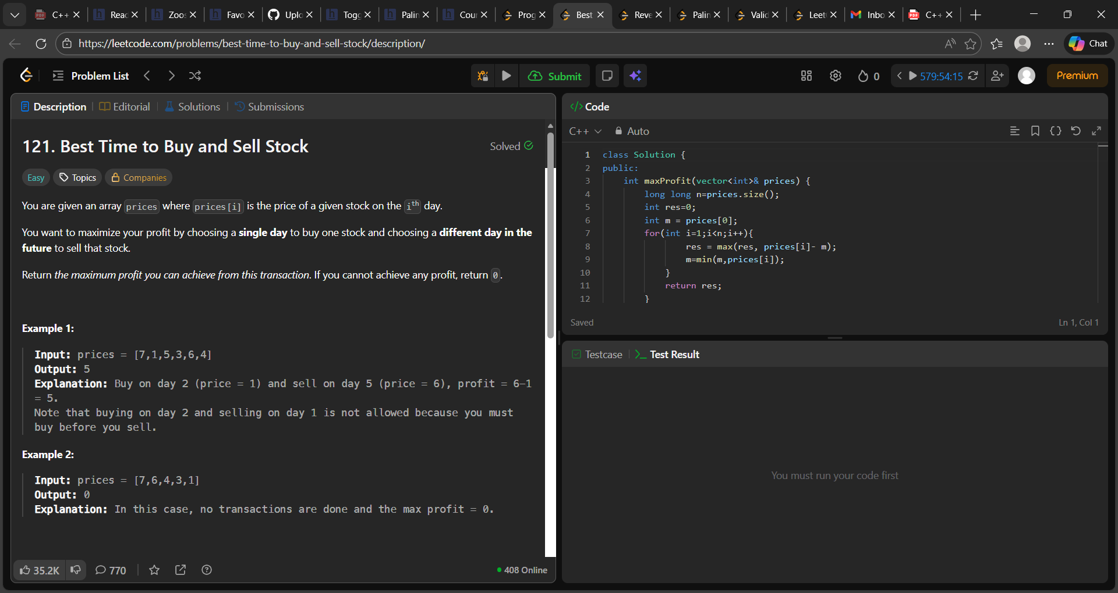

class Solution {
public:
int maxProfit(vector<int>& prices) {
long long n=prices.size();
int res=0;
int m = prices[0];
for(int i=1;i<n;i++){
res = max(res, prices[i]- m);
m=min(m,prices[i]);
}
return res;
}
};

